Comsats University Islamabad, Attock Campus
Information Security
Lab Mid Term
Submitted to
Ms. Ambreen Gul
By
Muhammad Yousaf Qazi | FA23-BSE-030

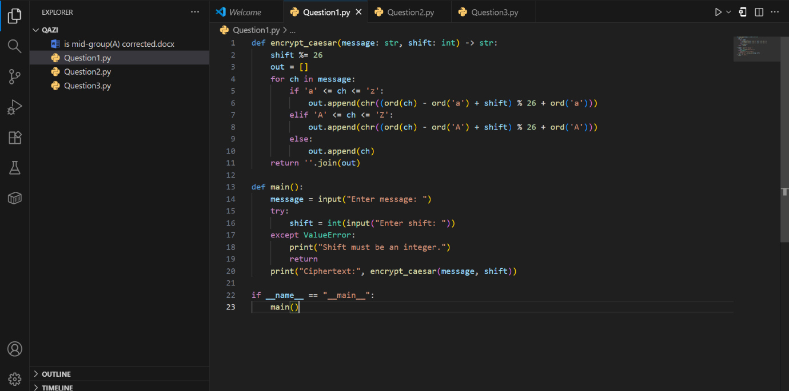
Question1

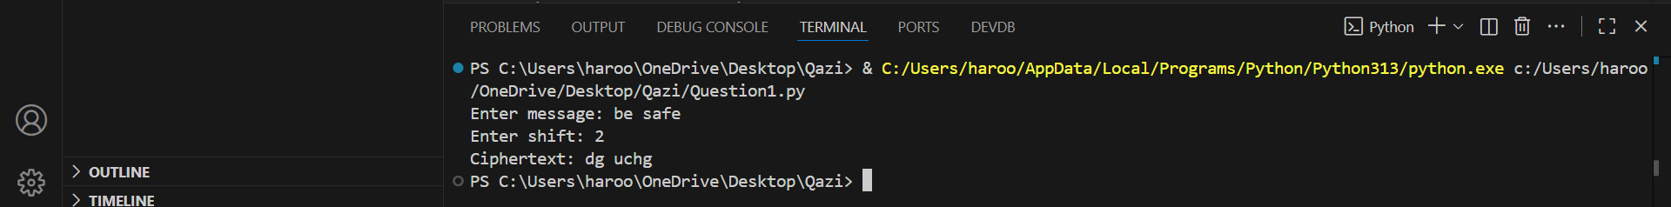
Output

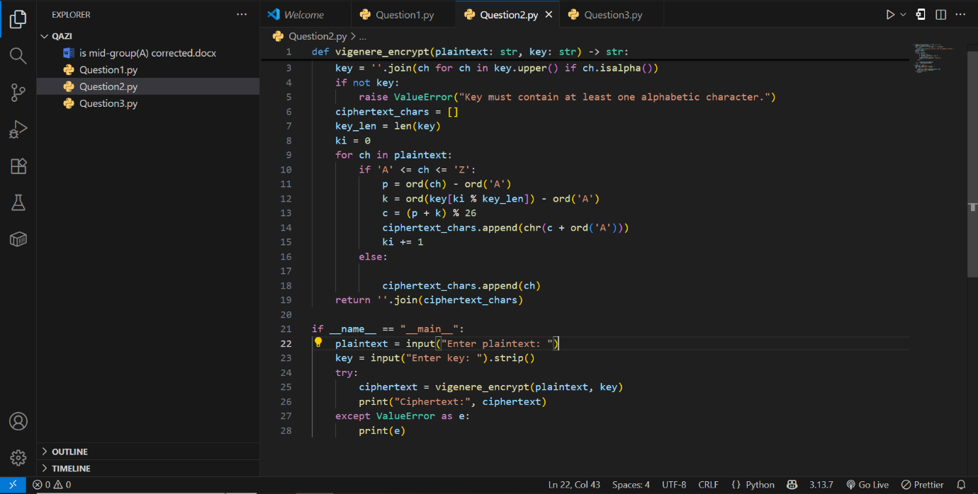
Question 2

Output
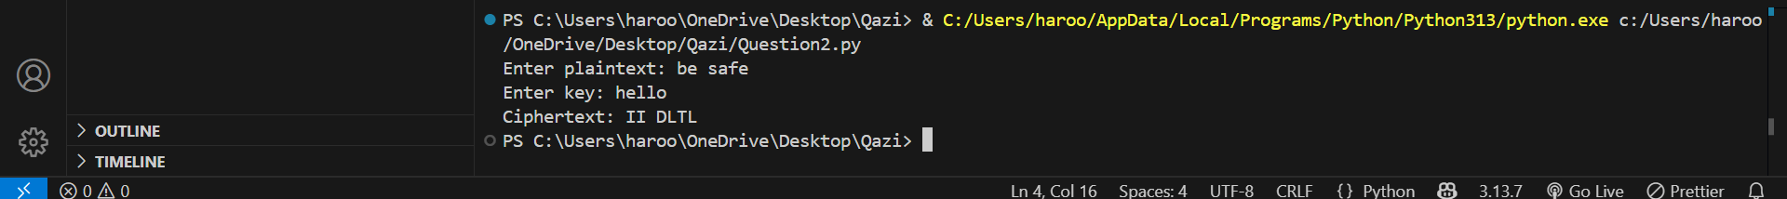
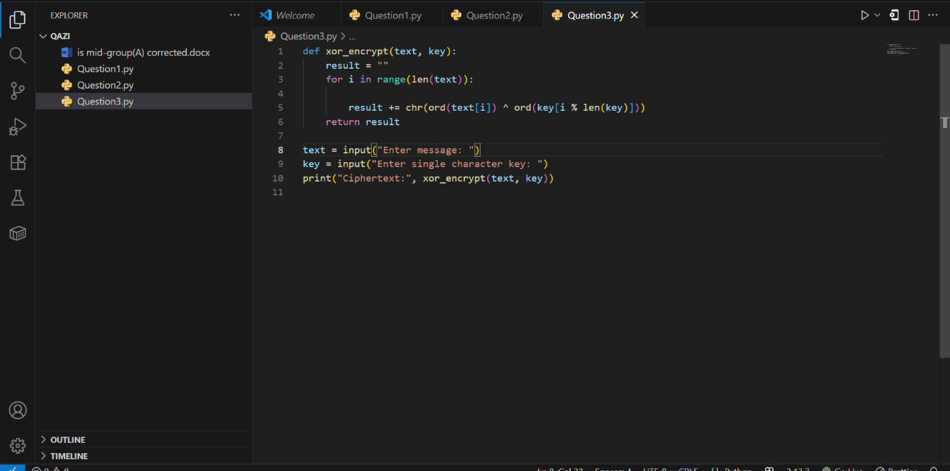
Question 3

Output
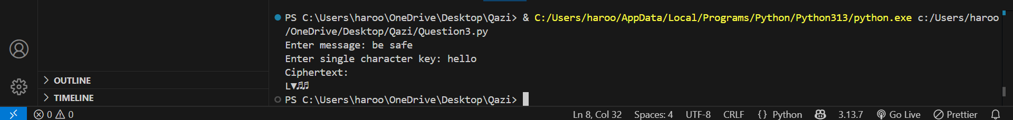
Question 5(a)
AES | DES
AES (Advanced Encryption Standard) uses 128-, 192-, or 256-bit keys and operates on 128-bit blocks. | DES (Data Encryption Standard) uses a 56-bit key and operates on 64-bit blocks.

(b)
AES has a fixed block size of 128 bits, which means it processes data in chunks of 128 bits.
One of the key sizes AES can use is 128 bits (others are 192 and 256 bits). This flexibility helps AES provide better security for different needs.
(c)
AES is more secure mainly because of its longer key sizes. DES uses only a 56-bit key, which can be cracked using brute-force (trying all possible keys) in a short time with modern computers.
AES’s 128-bit or higher keys make brute-force attacks practically impossible with today’s technology.

